Does Predictability Affect Reference Form? It depends on the verb

The structure of events appears to influence the way people talk about them. In some cases (see ex. 1), event roles have a much higher tendency to be mentioned again – that is, they are predictable. In emotion verbs like (1), Sandy is considered the expected cause of the scaring/fearing events, and is more likely to be mentioned again (Fukumura & van Gompel, 2010; Hartshorne et al., 2015; Kehler et al., 2008). In (2), Kathryn is the goal of the transfer event, and is expected to participate in the next event, thus making her more likely to be mentioned (Stevenson et al., 1994). Critically, these biases depend on the relation between the two clauses, where the implicit causality effects in (1) are supported by a causal continuation, and the goal bias in (2) is supported by a next-mention continuation.

1a. Sandy scared Kathryn because…  1b. Kathryn feared Sandy because… | 2a. Sandy threw the ball to Kathryn. Then…  2b. Kathryn caught the ball from Sandy. Then…

A debated question is whether thematic role predictability affects the use of reduced referential expressions, like pronouns. Sentence-completion experiments have yielded conflicting data, with some authors arguing that pronouns are more common for predictable referents (Arnold, 2011), while others presenting data that thematic roles have no effect on pronoun use (Fukumura & van Gompel, 2010; Kehler et al., 2008).
I present the results of a series of studies, which examined this question in detail. We designed a novel story-telling task, in which participants heard a description of one panel, and provided an oral description of the second panel (see Fig. 1).

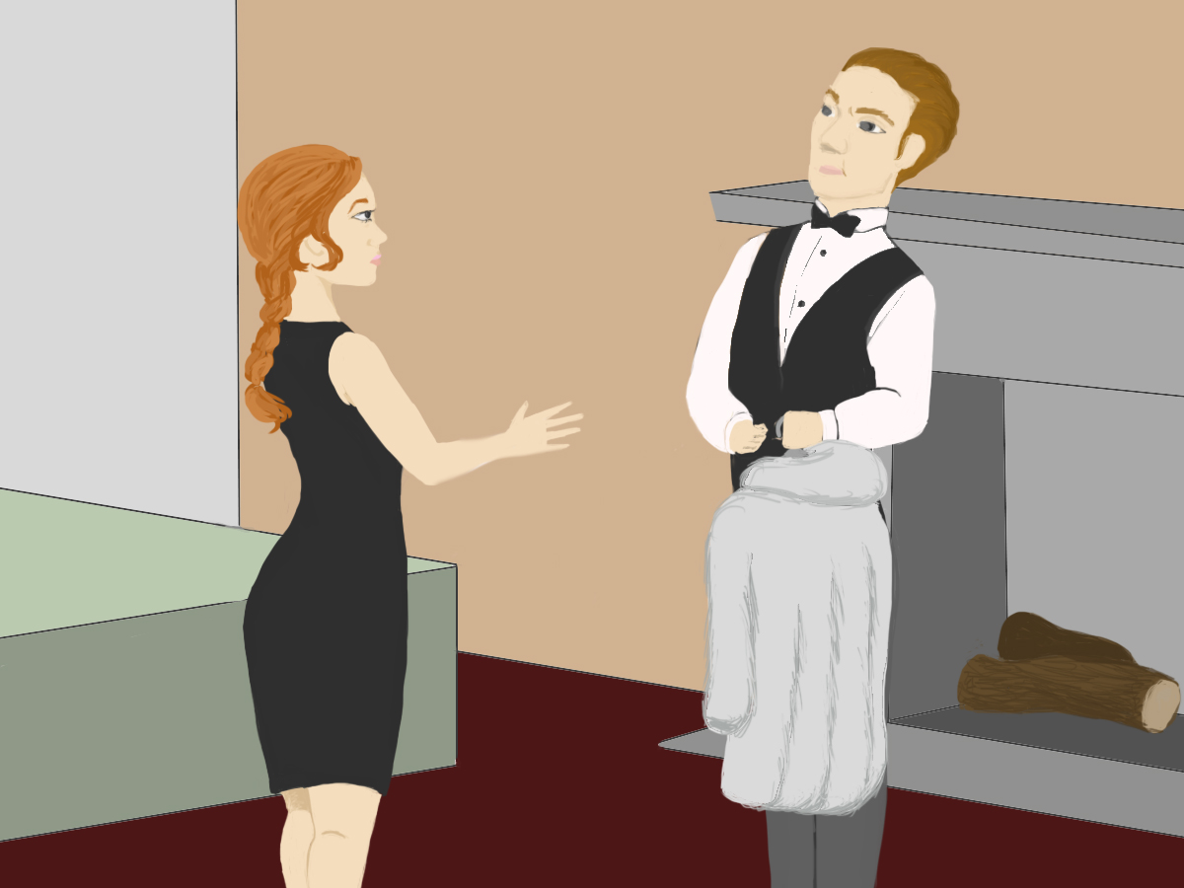 |  | Participant hears:  “The butler gave a fur coat to the maid” OR “The maid received a fur coat from the butler.”  Response: {The butler / He…}
In experiments examining goal-source verbs, we found strong support for the hypothesis that thematic role does influence referential form. However, experiments examining emotion verbs presented mixed results. A corpus analysis suggests that these verb types may differ in the way they are used in discourse, affecting both the perceived predictability of discourse entities, and their relationship to discourse accessibility.

Arnold, J.E. (2001). The effect of thematic roles on pronoun use and frequency of reference continuation. Discourse Processing, 31(2), 137–162.
Fukumura, K. & van Gompel, R. P. G. (2010). Choosing anaphoric expressions:… Journal of Memory and Language. 62, 52–66.
Hartshorne, J.K., O'Donnell, T.J., & Tenenbaum, J.B. (2015). The causes and consequences explicit in verbs. LCP, 30:6, 716-734.
Kehler, A., Kertz, L., Rohde, H. & Elman, J., (2008). Coherence and coreference revisited. Journal of Semantics, 25, 1-44.
Rosa, E. C., & Arnold, J. E. (under review). Predictability affects production: Thematic roles affect reference form selection. UNC Chapel Hill.
Stevenson, R., Crawley, R., & Kleinman, D. (1994). Thematic roles, focusing and the representation of events. LCP, 9, 519-548.

